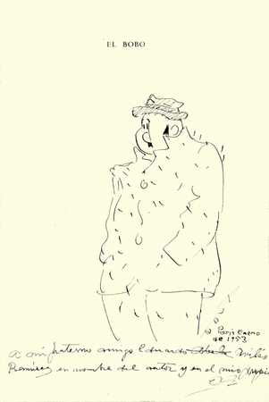

Eduardo Abela, *El Bobo (The Fool)*, 1953, ink on heavy paper laid down on cardboard, 8.75 x 6 inches, Cernuda Arte, http://www.cernudaarte.com/artists/eduardo-abela/